Stories from the Holy Qur'an
"Qisas min Al Quran"

 |  |  |  | 15 | : | No. of episodes | -
 |  |  |  | 13 min. | : | Duration of each episode | -
 |  |  |  | 6 – 11 Islamic religious | : | Target age | -
12 episodes 2D animation & 3 episodes 3D animation |  |  |  |  | : | Type (style) | -
It's done in Arabic and English dubbing |  |  |  |  | : | Notes | -

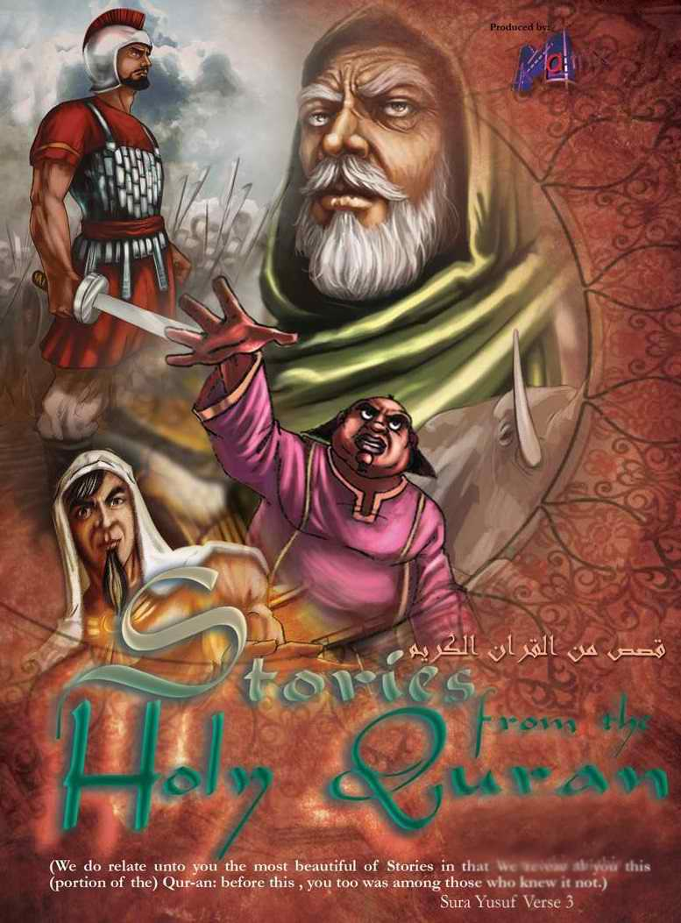
Overview:
This is the best quality, produced cartoon that explains stories from the holy Qur'an.
In each episode we present a story from the holy Qur'an stories and demonstrate it through the cartoon to show all details and circumstances of the story. These series have a privately Islamic nature that matches the Muslim child's needs for high quality Islamic work.
Stories from the Holy Qur'an, an essential for every Muslim home – Stories chosen by Allah, creator of the universe, beautifully animated to enlighten and inform. Legendary Tales filled with excitement and suspense that tell of good and evil, of life and faith. Meet characters who provide perfect role models for us and our children. Enjoy – Stories from the Holy Qur'an.
(We do relate unto you the most beautiful of Stories in that We reveal to you this (portion of the) Qur'an: before this, you too was among those who knew it not.); Sura Yusuf Verse 3.

Episodes Titles:
1- Qaroon 2 - The People of the Cave.
3 -The Two Farms Man. 4 - Saleh Camel.
5 - The People of Paradise. 6 - The Elephant 1
7 - The Elephant 2 8 - The pharaoh Believer.
9 - Suliman and the Ants. 10 - Israel Cow.
11 - Qabeel, Habeel and the Crow 12 - Taloot and Jaloot.
13 - Ashab Al Okhdood 1 14 - Ashab Al Okhdood 2
15 - Al Ozayr

Sample Episodes:
For samples screening; visit our website (egymatrix.com) or use the following links:
- Stories from the Holy Quran – Ep.: Heaven’s People (English version):
https://youtu.be/GCTpJZWgujo
- Stories from the Holy Quran – Ep.: Elephant’s People part 1 (English version):
https://youtu.be/iAcNFfNeXfI
- Stories from the Holy Quran – Ep.: Qaroun (English version):
http://youtu.be/gww8Ya2iFPs
- Stories from the Holy Quran – Ep.: As7ab El Feel "Elephant’s People" part 1 (Arabic version):
http://youtu.be/E40ZvU49JKs
- Stories from the Holy Quran – Ep.: As7ab El Janah "Heaven’s People" (Arabic version):
http://youtu.be/giAF1QoqL6I

